Basic concepts

An Algorithm is a step by step procedure for solving a problem or accomplishing some end
An Algorithm in computer science is a problem solving method suitable for implementation as a computer program.
It’s a set of rules a computer follows to achieve a particular goal

Most algorithms need data organized in a specific way to properly work. Data structures

Binary search is where we use the first part of an element and continue searching for it in the data by comparing its possible position and narrowing it down to a limited section of the data structure
In order to do this we need an ordered data structure.

Two kinds of problems :
- Computable problems : Algorithms capable of solving them
- Non computable problems : No algorithm capable of solving them

Algorithm analysis consists a series of techniques that allow us to compare algorithms solely based on their own characteristics.

For example if we wanna quantify the execution time of an algorithm then we :
- Quantify the number of operations or steps the algorithm will require
- Consider each step as a basic unit of computation, the execution time can be expressed as the number of steps required by the algorithm to solve the problem.

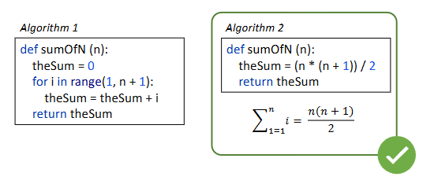
To estimate the number of steps in this problem we use the number of assignments as a basic unit of computation
The order of magnitude function describes the part of T(n) which increases the fastest as the value of n increases.
The order of magnitude is referred to as the Big O written as 0 (f(n)), where f(n) is the representation of the dominant part of the original T(n)
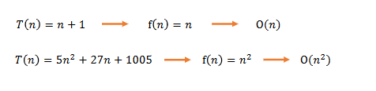
The big O c is commonly used to characterize :
Time complexity : how much time the algorithm will take
Space complexity : How much memory the algorithm will use
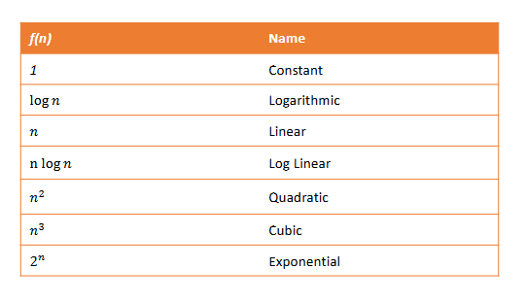
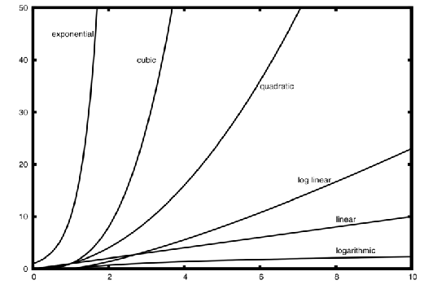

The big O is only an asymptotic analysis. An algorithm can be slower but very efficient on a limited amount of data or a specific type of data
Two algorithms can have the same computational complexity but one can perform better than the other.
Note that the Big O measures the asymptotic upper bound , In other words the worst case scenario.
Performance of an algorithm can be characterised as worst, average and best case.
The big O is the worst case scenario
The Big-Ɵ and Big-Ω are notations for average and best case
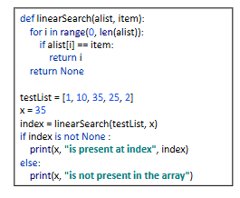
The worst case is where the for loop has to go through each element in the list and doesn’t find
Average case is at half of the list
Best case is the first element
Worst case : n Average case : n Best case : 1 (avg case n/2 is asymptotically n)
A Data structure is a particular way of organizing data in a computer so it can be used affectively
An abstract data type (ADT) is the logical description of a data type and of its operations
An ADT is Implementation-independent, meaning we can have different implementations of the same ADT but each such guarantee the same interface to the structure.
A Data structure is the implementation of an ADT
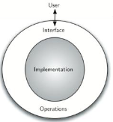

For example we know what the sqrt function will do but we do not know how its implemented
For example when we use a list we are able to add, remove, search and get number of elements

Data structure categorization

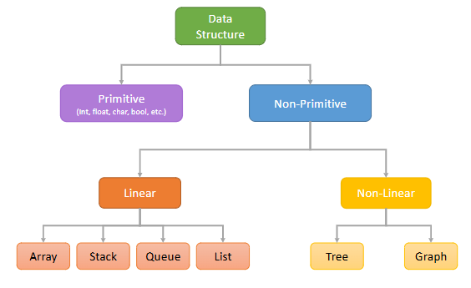

Built in python data structures :
- Int
- Float
- Bool
Collection data types (CDT) :
- Ordered : list, string, tuple
- Unordered : Set, dictionary

In python terminology of its built in data : Ordered means that the items maintain the order of insertion and can be referred with an index
Unordered means that the items does not maintain an order of insertion and cannot be referred with an index.
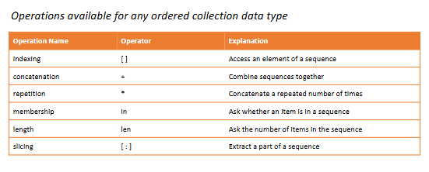
A list is an ordered collection of zero or more references to python data objects
Ex : MyList = [1,2,3,3]

Lists are Heterogeneous , meaning they do not need to be in the same class
They are mutable , meaning items can be added, removed and modified

Lists in python are an implementation of the List ADT
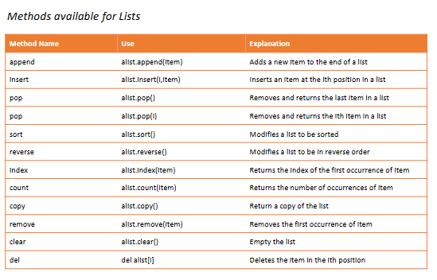

A tuple is a heterogenous sequence of data
Ex : MyTuple = (2, “blah”,222)
Tuples are immutable

A String is a sequential collection of zero or more characters
Strings are also immutable

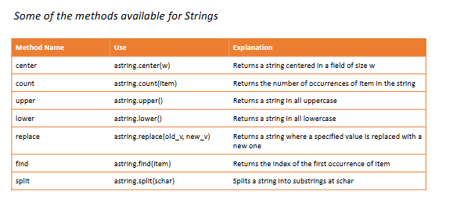

A Set is an unordered collection of zero or more heterogenous and mutable python data objects
Ex : MySet = {2,3,”blah}

Sets do not allow duplicates
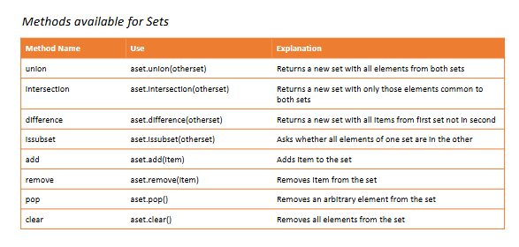

A Dictionary is an unordered collection of pairs of items with each consisting a key and a value
Ex : Dict1 = {“Italy”:”rome”, “France”:”spain”}

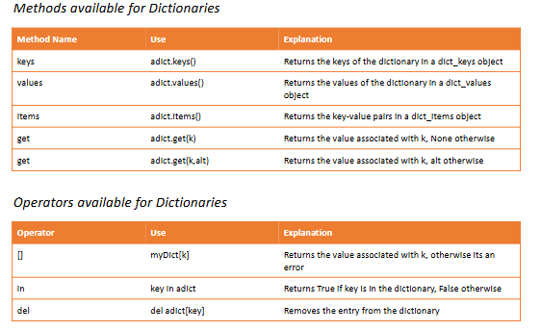

Each structure is implemented to make its common operations faster
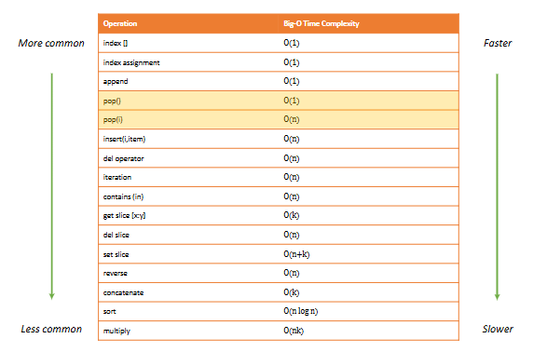

Dictionaries are extremely fast at set,get,delete, in operations
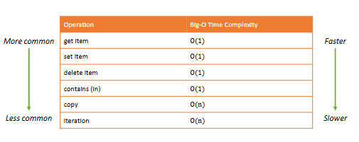
However dictionaries have a high memory occupation

